🔗 How they work together (real-world flow)
Let’s put all four tools in a realistic order:
🧠 Full DevOps pipeline example
- OpenTofu
  - Creates VMs, networking, load balancers
- Ansible
  - Configures those VMs (Docker, K8s prerequisites, users)
- Kubernetes
  - Runs and orchestrates applications
- Jenkins
  - Automates builds, tests, deployments into Kubernetes

Mental model (very important)
Tool | Manages | Level
OpenTofu | Infrastructure | Cloud / Hardware
Ansible | OS & configuration | System
Kubernetes | Applications | Runtime
Jenkins | Automation workflows | Process

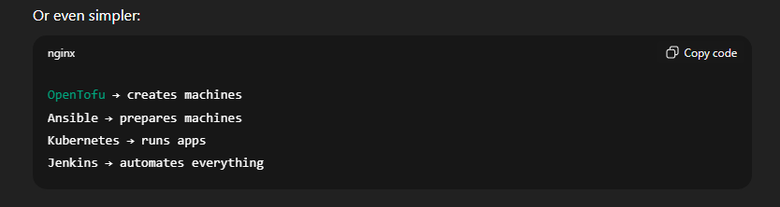

Straight talk (coach mode)
- If you understand Kubernetes, these tools make sense around it
- Don’t learn them randomly — learn them in this order:
  - OpenTofu basics
  - Ansible fundamentals
  - Jenkins pipelines
- This stack is extremely employable in cloud & DevOps roles
If you want, next I can:
- Compare Ansible vs Kubernetes responsibilities (common confusion)
- Show a simple Jenkins pipeline that deploys to K8s
- Or map these tools to real job roles (DevOps, SRE, Cloud Engineer)

